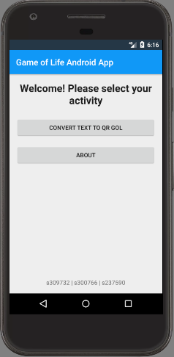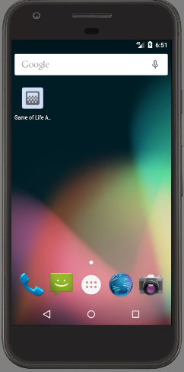Game of Life Android Application  
Project Documentation

Programutvikling (ITPE1600/DATS1600)  
Høgskolen I Oslo og Akershus, Oslo 2016/2017

# Activity structure and function

## Activity_main

This is the first activity and as such should greet the user and be generally simple to understand. This is where our app displays the user its currently implemented functions, and is set up as to be open to added functionality in the future.

## Activity_text_qr

A simple editText field with a prompt to enter a text for the user and a button to pass the text to the next activity. Displays a message (“toast”) with a short lifespan to prompt the user to enter a message if they try and submit an empty textField. If the message surpasses 500 characters, the application displays a toast with a longer lifespan, the character limit and the current character count to the user. This was done as to not risk that the user has a display with a resolution so low that the cells are not shown at all since the cell size is decided by the screen width (ref. 1.2 *Activity_text_qr_gol*), and QR codes for a text with over 534 characters are overly detailed (90x90 “modules).

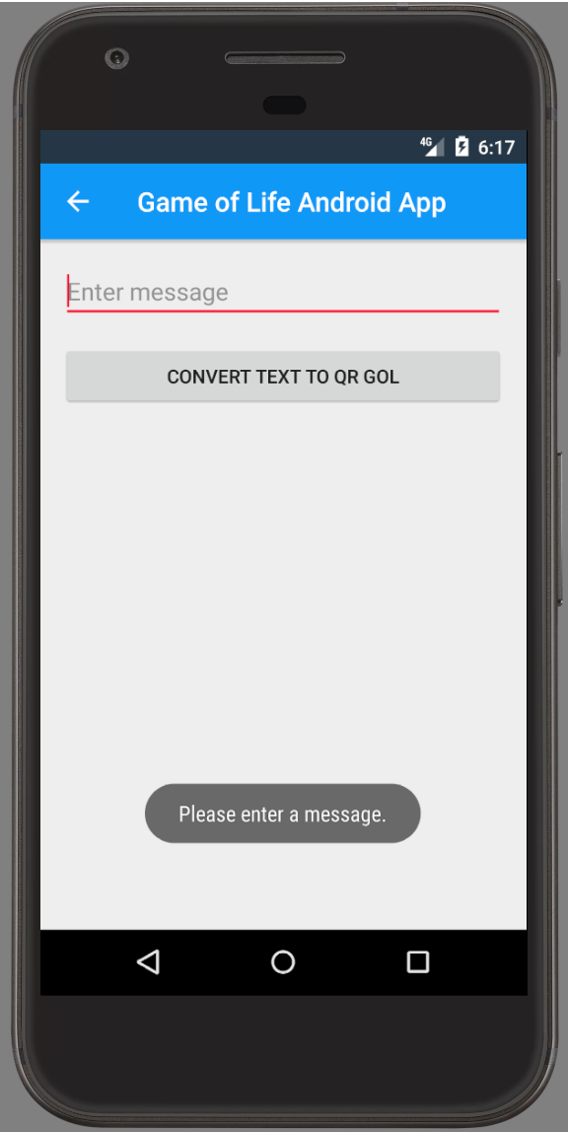 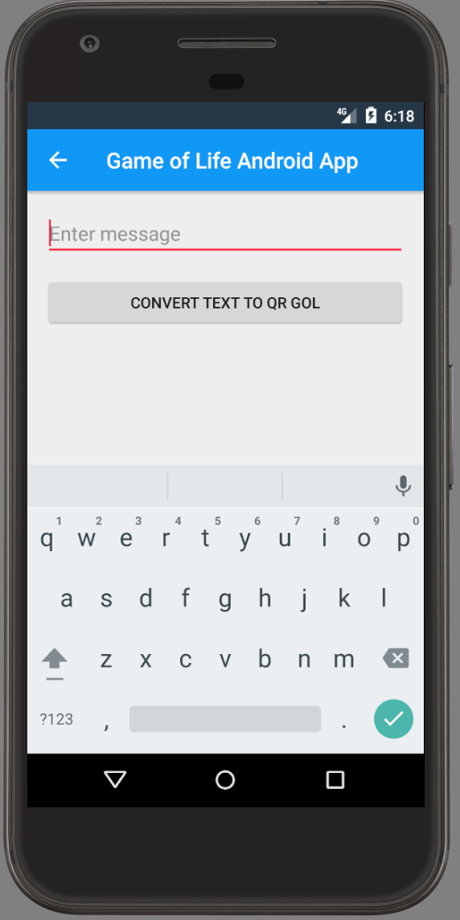 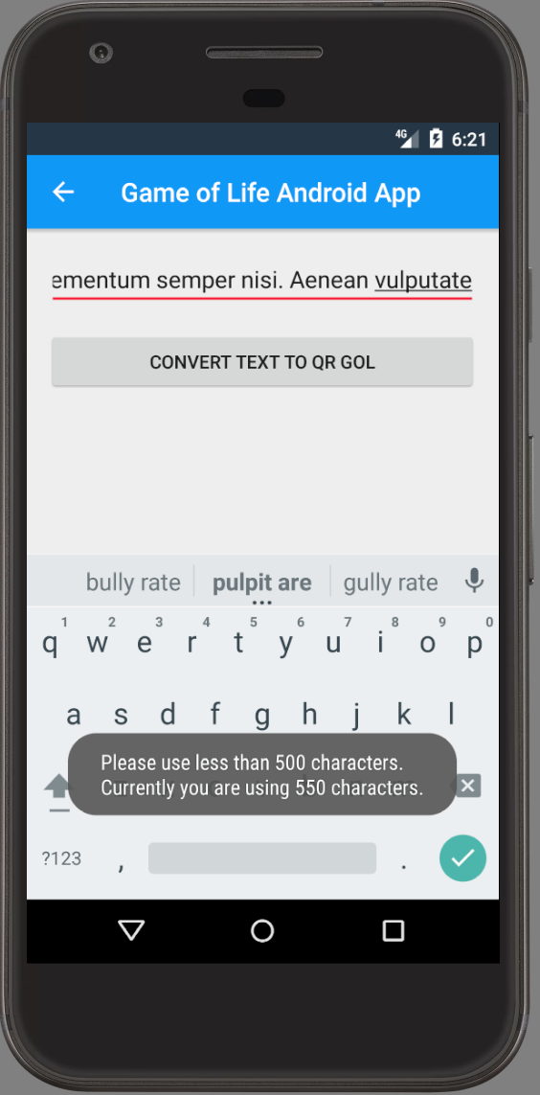 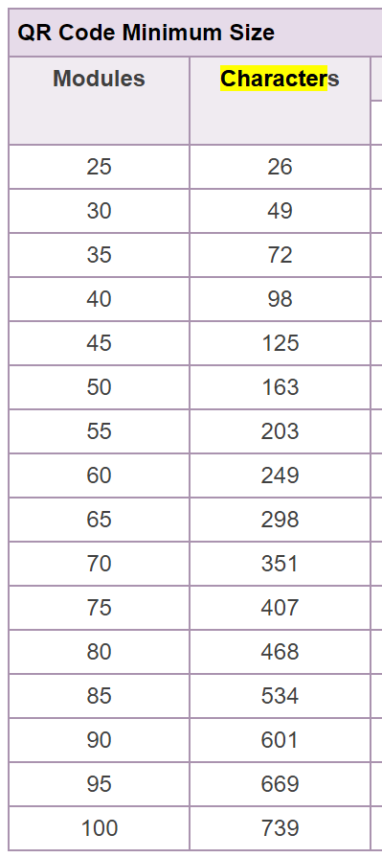

Table source: <http://blog.qrstuff.com/2011/11/23/qr-code-minimum-size>

## Activity_text_qr_gol

The device screen width is separated into chunks based on the x-axis of the board, the QR Code is set to the middle of the 2D array and gets drawn. The users` message gets displayed at the bottom (and shortened if it is longer than 80 characters) and the user has the choice of playing the nextGeneration of their QR Code GoL, or starting the Animation, where the thread sleeps for 300 milliseconds, then draws its next generation. This timing was chosen as a compromise, as it is fast enough to give the illusion of an animation, while not suffering from uneven, “choppy” animation if the device processor is older.

